**Project Management and Resource Tracking System**

Purpose of the System: This system is designed to manage projects, departments, clients, employees, and the tools used in executing various tasks. It supports functionalities such as employee assignment to departments and projects, tracking tools usage, and logging work hours.

**Entities Overview:**

1. **Employee**

* Description: Staff members of the organization.
* Attributes: EID, Ename, Age, Salary, D_EID, E_DID
* Relationships: Manages other employees, works in departments, works on projects, uses tools

1. **Department**

* Description: Company departments
* Attributes: DID, Dname, Count, D_EID
* Relationships: Has many employees, managed by an employee.

1. **Client**

* Description: Customers who request projects.
* Attributes: CID, Cname, Email
* Relationships: Requests projects, belongs to one or more categories.

1. **Category (Multivalued Attribute)**

* -Description: Represents categories a client belongs to (e.g., Government, Private, Non-Profit)
* Attributes: CID, Category
* Note: This is a multivalued attribute, allowing clients to belong to multiple categories. Therefore, it's stored in a separate table to maintain normalization.

1. **Project**

* Description: Contracted work for clients
* Attributes: PID, Pname, Cost, Pdate, P_CID
* Relationships: Requested by clients, employees work on them.

1. **Tool**

* Description: Physical/software tools for projects
* Attributes: TID, Tname, Cost
* Relationships: Used by employees in projects.

1. **Work_Hours**

* Description: Tracks the hours employees work on projects.
* Attributes: W_EID, W_PID, WorkHours

1. **Use**

* Description: Tracks tool usage in projects
* Attributes: U_TID, U_PID, U_EID

1. **Users of the System:**

* Admin - Full access, manage everything, generate reports.
* Project Manager - Assign employees, monitor work, track cost.
* Department Manager - Oversee departments and staff
* Client Relation Officer - Manage client data.

1. **Normalization Achieved**

* 1NF: Atomic values.
* 2NF: Partial dependency removed via junction tables
* 3NF: No transitive dependency

1. **Code output:**

* select * from project;

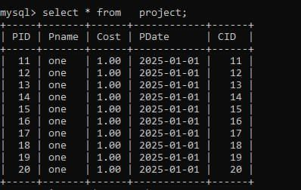

* select * from category;

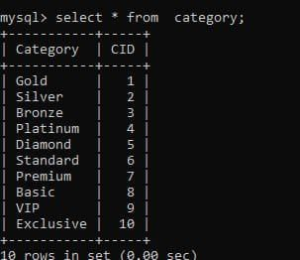

* select * from employee_department;

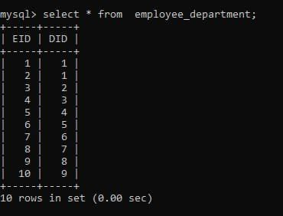

* select * from use_tool;

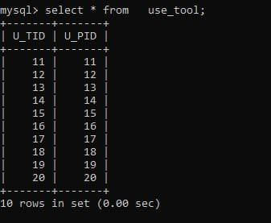

* SELECT C.Cname, COUNT(P.PID) AS Project_Count FROM Client C JOIN Project P ON C.CID = P.CID GROUP BY C.Cname;

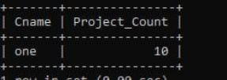

SELECT Ename, Salary FROM Employee order by Salary DESC;

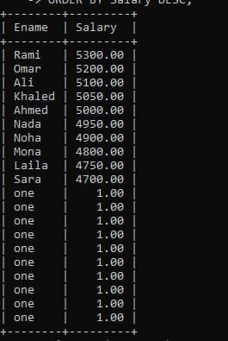

SELECT D.Dname, COUNT(ED.EID) AS Employee_Count from Department D JOIN Employee_Department ED ON D.DID = ED.DID group BY D.Dname HAVING COUNT(ED.EID) > 1;

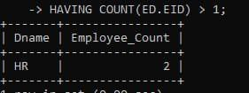

SELECT D.Dname, COUNT(ED.EID) AS Employee_Count FROM Department D JOIN Employee_Department ED ON D.DID = ED.DID GROUP BY D.Dname;

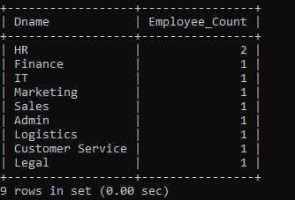

SELECT E.Ename, D.Dname FROM Employee E JOIN Employee_Department ED ON E.EID = ED.EID

JOIN Department D ON ED.DID = D.DID;